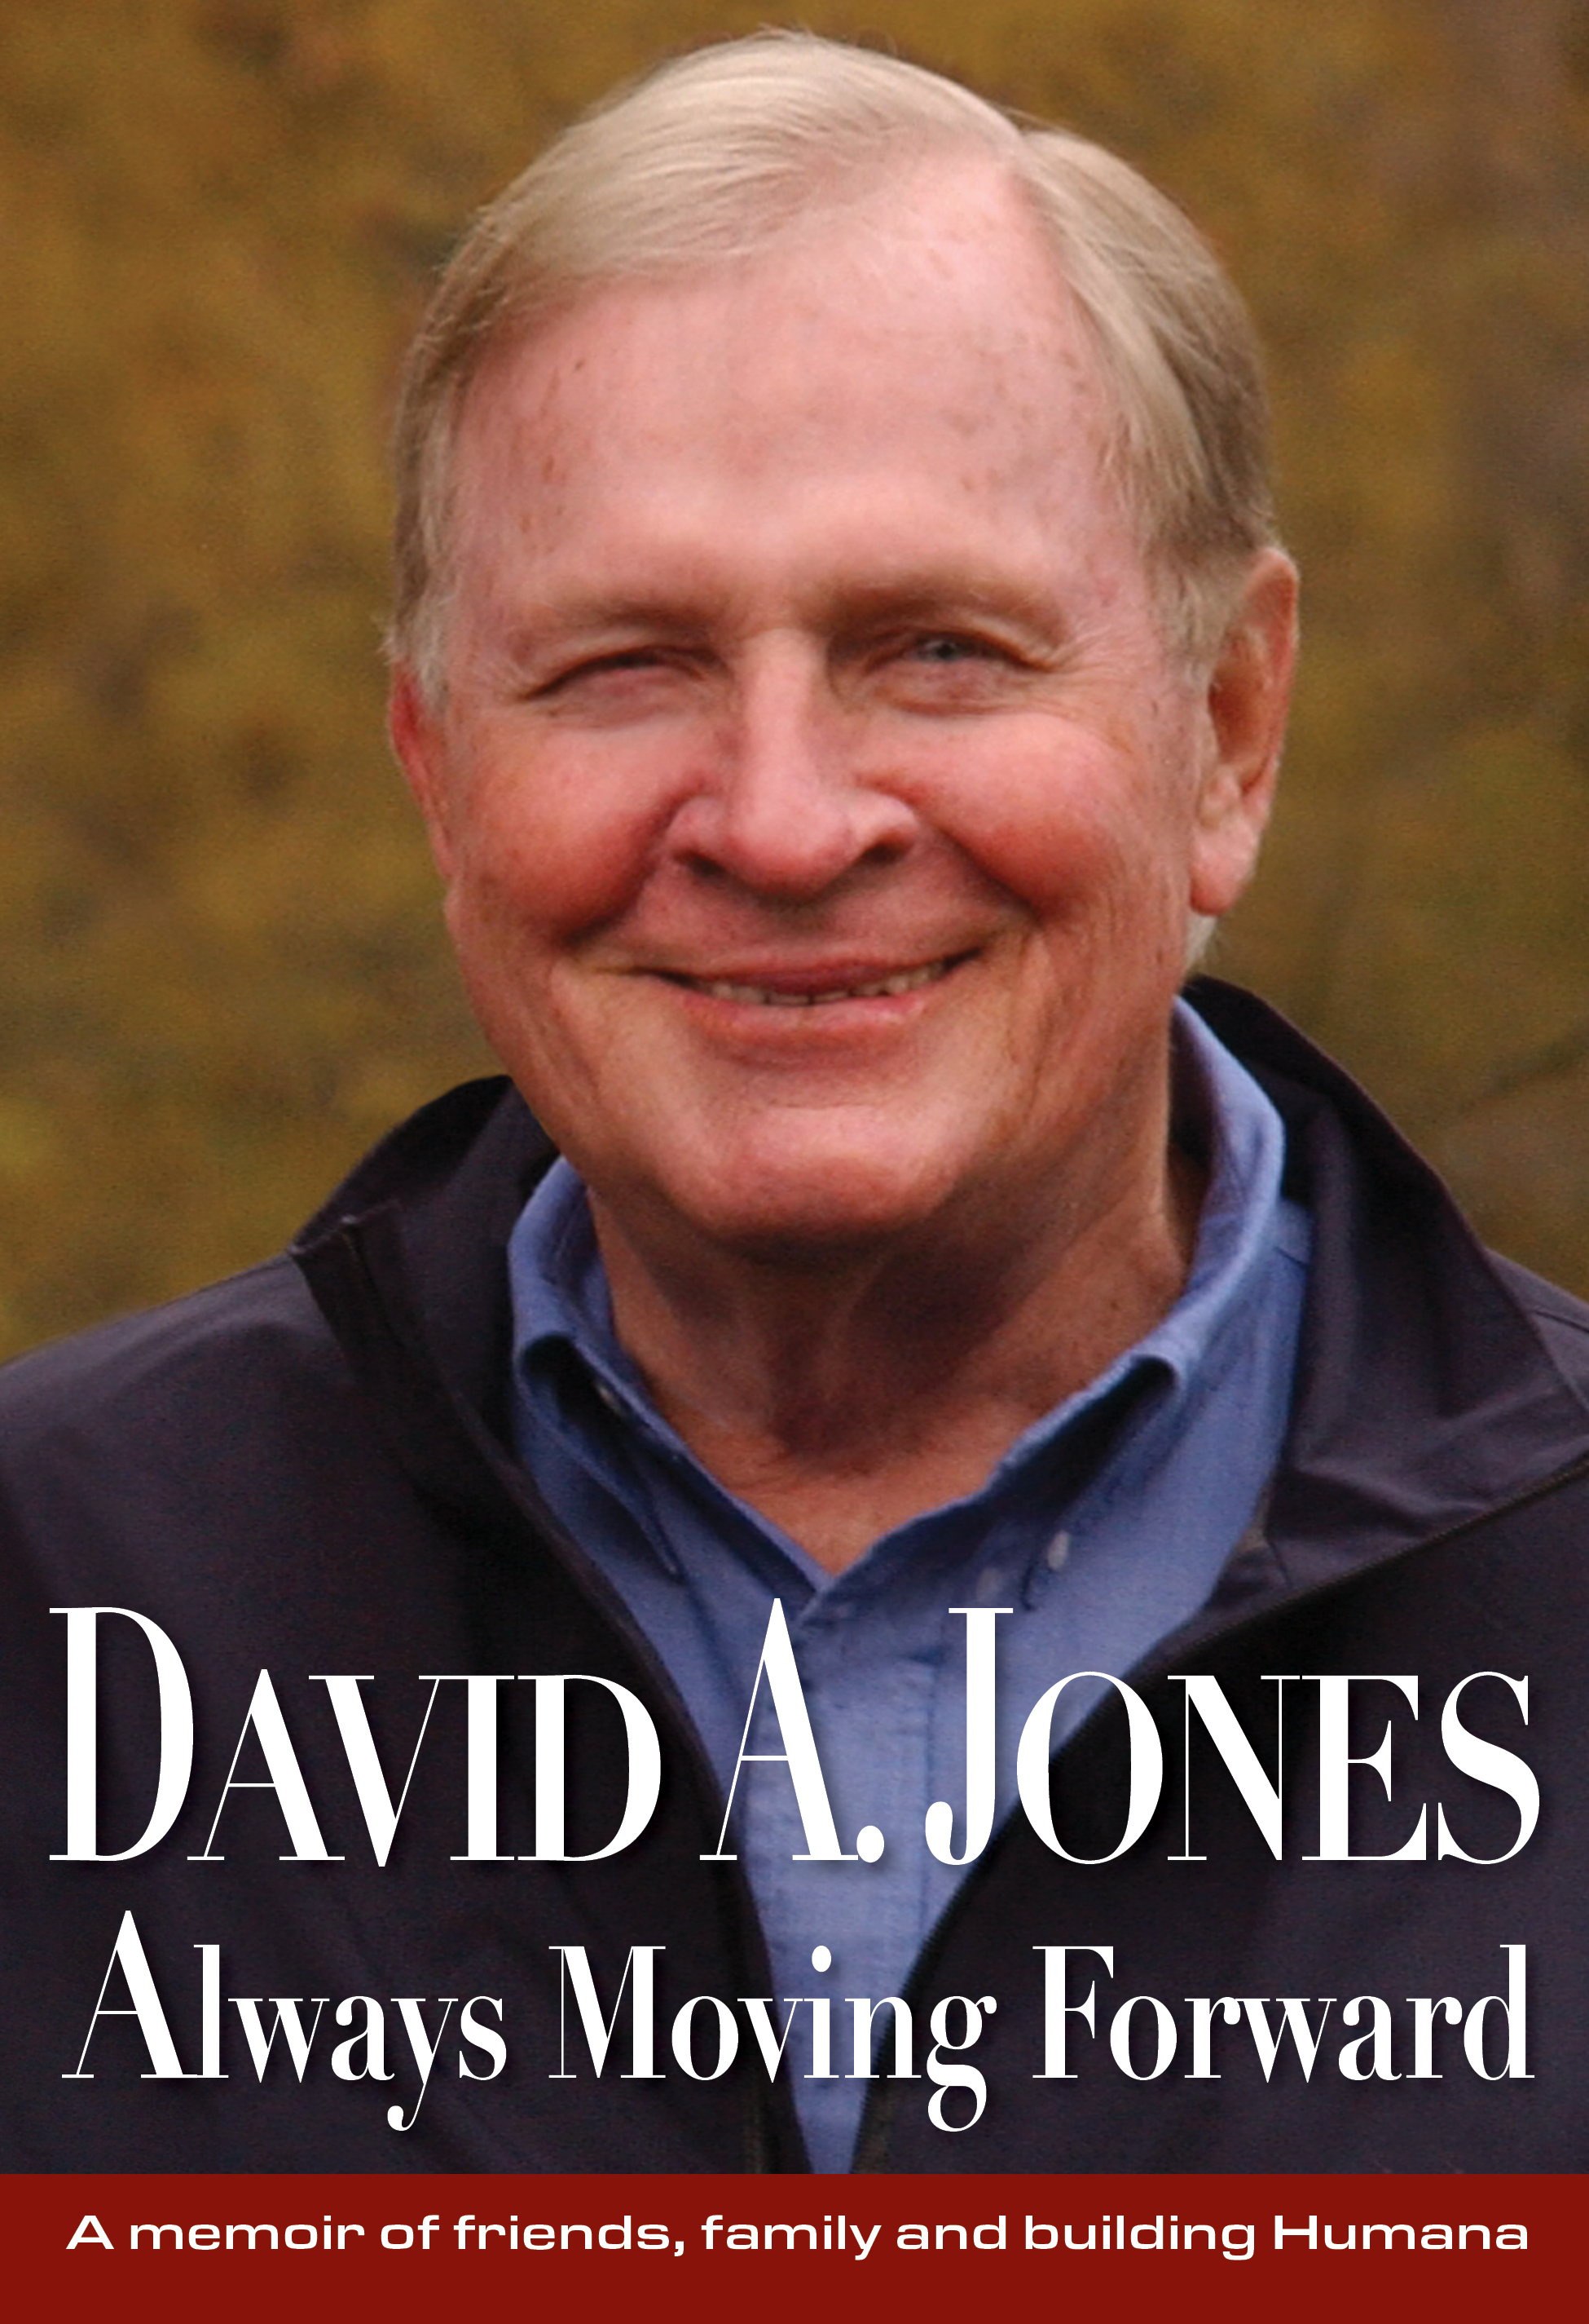

Title: DAVID A. JONES Always Moving Forward
Subtitle: A memoir of friends, family, and building Humana
Author(s): David A. Jones with Bob Hill
Category: Memoir/Autobiography
Publisher: Old Stone Press
Imprint: Old Stone Press
Pub Date: 10/10/23
ISBN13: 978-1-938462-63-4 (hard cover + dust jacket)
978-1-938462-64-1 (ePub)
Season: all
Format: Hard Cover, ePDF and ePub
Trim Size: 6.25 X 9.25
Page Count: 473
Carton Qty: 16 (34 lbs. each)
Illustrations: 50 photos, maps and illustrations
Audience: general/trade
Distribution: Baker & Taylor, Ingram, Amazon, Barnes & Noble, and all major
Internet outlets
Price: $34.95 (Hard Cover)
$14.99 (eBook)

BISAC Category: BIO003000 BIOGRAPHY & AUTOBIOGRAPHY / Business
BIO026000 BIOGRAPHY & AUTOBIOGRAPHY / Personal Memoirs
BIO013000 BIOGRAPHY & AUTOBIOGRAPHY / Rich & Famous

Description

The story of friends, family, hometown values – and an entrepreneur who changed American healthcare forever.
In 1961, David Jones and another young lawyer borrowed $1,000 each to build a nursing home. That modest investment turned into Humana: first the largest nursing home company in the U.S., then the largest hospital corporation, and today one of the nation’s largest health insurance companies, with 65,000 employees and a value of $65 billion.
“I’ve always believed there’s nothing being done that can’t be done better,” Jones writes in this engaging account of American entrepreneurship. He also advocates hiring ordinary people who learn fast and get things done, rather than relying on expert credentials.
But DAVID A. JONES Always Moving Forward is about so much more:

- The controversy over for-profit medicine: Jones explains why he was “proudly not non-profit.”
- The artificial heart: The world watched as a Humana team implanted the Jarvik-7 into a man who lived 620 days.
- A sixteen-year-long humanitarian mission: After the collapse of the Berlin wall and Eastern European economies, President George H. W. Bush asked Jones to help rebuild the Romanian healthcare system, which had been devastated by war and a corrupt dictator.
- 9/11: Jones and 23 Humana executives were at Ground Zero when the planes hit. They tell the harrowing story.
- Life lessons learned: For example, “Family first” and “You don’t have a clear idea unless it fits on the back of a business card.”
- Business failures as well as successes.
Jones also was a great philanthropist, although mostly anonymously. His final legacy is one of the largest metropolitan parks completed this century – a project led by him and one of his sons in their hometown of Louisville, Kentucky.

An inspiring autobiography of the man who co-founded Humana, gave away most of his billion-dollar fortune, and managed to get home for dinner almost every night.

Author Credit
David A. Jones, Sr. was co-founder, CEO and chairman of the board of Humana. He retired in 2005.
Bob Hill, a Louisville writer, helped Jones with this book. Hill has won many awards for his writing, including the Ernie Pyle Legacy Award, which recognizes the ability to connect with people and tell their stories. Hill did that for 33 years in 4,000 columns he wrote for the Louisville Times and Louisville Courier Journal, and in the ten books he has authored. This was a joyous project for both Jones and Hill, as they swapped stories and discovered similarities in their early lives.

Contributors
David A. Jones, Jr. (Editor), and family representative for his father’s memoir project. David's current passions include improving end-of-life care for patients, their families and community caregivers; preserving, and learning to play, American roots music; supporting student-focused improvement in public education; and rejuvenating local journalism.
He co-founded Chrysalis Ventures in 1993 in Louisville, KY, in the belief that focused financing for entrepreneurs was lacking “between the coasts.” This belief arose early, as he watched his father found and lead Humana Inc. – whose board he joined in 1993 when the company exited its industry-leading hospital business and re-invented itself as an insurer.
At Chrysalis David has partnered with young entrepreneurial companies in healthcare, education, telecommunications, and location-based entertainment. He’s continued to serve on Humana’s board, chairing it through the founders’ transition and now leading its governance committee. He is the eldest son of David A. Jones, Sr.
Jill Johnson Keeney (Editor) Founder of Moocow Communications, Editor and writer at New West, California, and Ms. magazines, The Louisville Courier Journal and a communications consultant at Humana.
Julia Comer, book designer, born and educated in Europe and Israel, Julia Comer has lived all over the world but calls Louisville, Kentucky her home. Her passion for design and art has guided a visual arts career that has included many years of graphic design practice and interior projects. Inspired and informed by her vast experience of fine art and craft, she curated and managed Objects of Desire and Flõ galleries creating her own line of sculptural jewelry. Julia’s work includes numerous projects including book design, branding, visual identity, environmental design, print, and web.

Publicity/Reviews
KIRKUS Review
Clarion Foreword Reviews

Awards

Author Appearances
October 16, 2023, Kentucky Author’s Forum, https://kentuckyauthorforum.com/
December 7, 2023 The Filson Historical Society https://filsonhistorical.org/

Distribution
Baker & Taylor and Ingram
Popular Internet outlets

Media Contact
John Clark, publisher Old Stone Press
Email: john@oldstonepress.com
Phone: 502.693.1506

Dan Hartlage, Guthrie/Mayes (gmPR)
Email: dhartlage@guthriemayes.com
Phone: 502.741.0969

Marketing Materials
High-resolution cover images are available from Old Stone Press

Websites/Social Media
www.oldstoneopress.com
Facebook and Twitter @oldstoneclark

