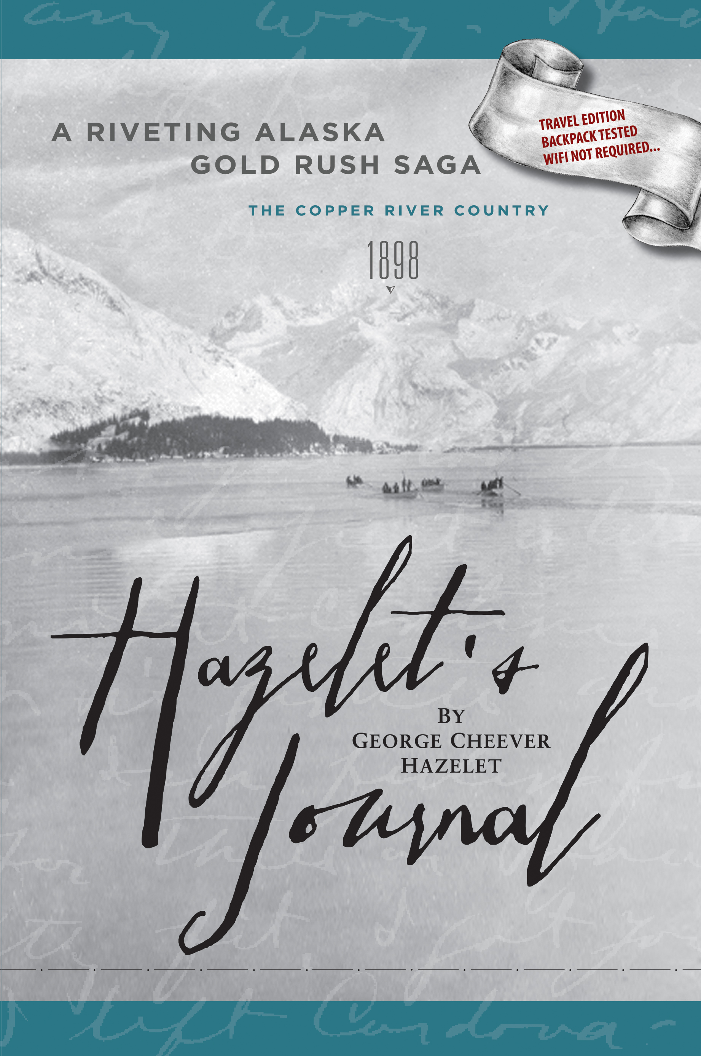

Title: HAZELET’S JOURNAL Travel Edition
Subtitle: A Riveting Alaska Gold Rush Saga
Author(s): George Cheever Hazelet
J. H. Clark, publisher/editor
Publisher: Old Stone Press
Imprint: Old Stone Press
Pub Date: 09/01/22
ISBN13: 978-1-938462-59-7 Travel Edition (paperback)
978-1-938462-60-3 Travel Edition (eBook)
Related ISBN 13: 978-1-938461-00-9 (hardcover + dust jacket)
Season: all
Format: paperback
Trim Size: 6 X 9
Page Count: 316
Carton Qty: 22
Illustrations: 185 photo, maps and illustrations
Audience: general/trade
Previous Edition ISBN: N/A
Price: $17.95 (paperback)
$ 7.99 (eBook)
BISAC Category: BIO023000 BIOGRAPHY & AUTOBIOGRAPHY / Adventurer & Explorers
TRV025130 TRAVEL / United States /West/Pacific (AK, WA, CA)

Description
Hazelet's Journal is a true 1898 Gold Rush story that gives us insight into the character of those who went before us, a sense of passion, loyalty, and resilience that was so much a part of the great American spirit that our country was founded upon. It's told in the journalist's original voice, captured for generations to come.
This Travel Edition is designed in a paperback format, lightweight to fit inside a backpack to read (no wifi required) on the trail as the traveler makes his or her way to Valdez. It contains the same journal entries and stories contained in the hardcover version published in 2012, however with more travelogue content of the current sights and landscapes as one makes their way (300 miles) along the Richardson Highway from Anchorage into the town of Valdez, the staging site of the old 1898 pioneer tent city and trailhead of the Alaska Gold Fields.
A rich history of the last true American frontier to experience. The old Copper Center and pioneer mail hub at the confluence of the Copper and Klutina Rivers. Kennecott Cooper mines at McCarthy, Keystone Canyon with its beautiful waterfalls and the scene of the famous "shootout" between waring railway companies in 1907, and much much more for the curious travelers to experience as they make their way into the town of Valdez. Discover the magic!
Come see the "Stones."
This Valdez public art space honors George Cheever Hazelet, Andrew Jackson Meals, and the region’s Indigenous people before them including those who were so important in guiding them into the gold fields. The name for the Meals Hill trailhead is VALDEZ RISING - "Suacit" (The People Of The Place That Rises Into View), recognizing the Alutiiq-Sugpiaq of the region and the many partnerships that persevered to make Valdez and Alaska what they are today.
VALDEZ RISING - "Suacit" will speak to people in many ways. It will be a place to learn about the early history of Valdez and hopefully be a quiet spiritual place of reflection, or a hub for conversation about the future. It will be a meeting place before hiking into Meals Hill Parkland. Handicap accessible and senior-friendly.

Author/Editor Bio
John Clark received a BA in fine arts from the University of New Mexico and founded and ran a printing and manufacturing company located in Louisville, Kentucky for twenty-seven years. Today, he is the president of the Port Valdez Company, which traces its land holdings to George Cheever Hazelet and his partner Andrew Jackson Meals original scripting of 720 acres in Valdez, Alaska, at the turn of the twentieth century. He also is the founder of Old Stone Press. He and his wife, Gretchen, live in Louisville, Kentucky.

Publicity/Reviews
Alaska Historical Society
Courier Journal (Louisville, KY)
KIRKUS Review
Clarion ForeWord Reviews

Awards
Clarion ForeWord Reviews Book of the Year Finalist
Finalist IBPA Benjamin Franklin Award—Two categories~Autobiography/Memoir and History
IBPA—cover design award

Author Appearances
July 17, 2013 6:30 PM: Louisville Free Public Library, 3940 Grandview Ave., Louisville, KY 40207
July 19, 2013 7:00 PM: Carmichael’s Bookstore, 2866 Frankfort Ave, Louisville, KY 40206

August 20, 2013 7:00 PM: Anchorage Museum at Rasmuson Center, 625 C Street, Anchorage, AK 99501
August 23, 2013 12 noon & 7 PM: Valdez Museum, 217 Egan Drive, Valdez, AK 99686

Distribution
Baker & Taylor and Ingram
Popular Internet outlets

Media Contact
John Clark, publisher Old Stone Press
Email: john@oldstonepress.com
Phone: 502.693.1506

Marketing Materials
High-resolution cover images are available from Old Stone Press

Websites/Social Media
www.HazeletsJournal.com www.iceboundempire.com www.oldstoneopress.com
Facebook and Twitter @hazeletsjournal

