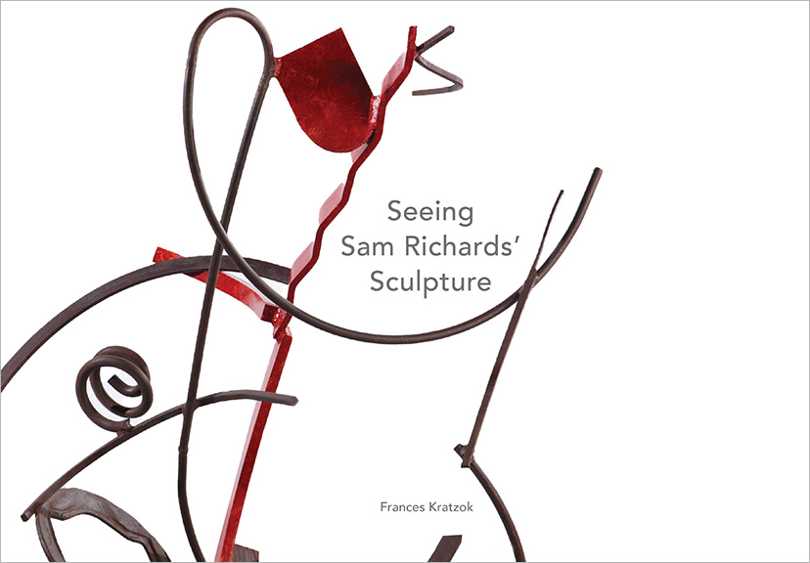

Title: SEEING SAM RICHARDS’ SCULPTURE
Author(s): Frances Kratzok
Art Direction: John Begley
Publisher: Old Stone Press
Imprint: Old Stone Press
Pub Date: January 10, 2022
ISBN13: 978-1-938462-56-6 (hardcover)
ISBN13: 978-1-938462-58-0 (eBook)
Library of Congress: 2021921782
Format: landscape
Trim Size: 11-1/2 X 8
Page Count: 200
Carton Qty.:
Illustrations: 190+ color
Audience: Trade/General (Adult)
Price: $60.00 Retail (hardcover),
$14.99 (ebook)

BISAC Category: ART026000 ART / Sculpture & Installation
ART027000 ART / Study & Teaching
ART053000 ART /Techniques / Sculpting

Introduction
by John P. Begley, Former Gallery Director, Assistant Professor of Fine Arts Emeritus, Hite Art Institute, University of Louisville

I have known Sam Richards since 1976 when I produced an invitational exhibition of his sculpture at the New Harmony Gallery of Contemporary Art. I say, “have known” him, despite his untimely death in 1994, because since then I have produced two additional solo exhibitions of his work, and to know his work is to know Sam.

Sam was reserved, but his work was so carefully considered that it speaks visually extremely clearly. I know this type of communication is often understood only intuitively, yet its power is inherent in its confrontational physicality, its human scale and enigmatic silence to usual verbal description. Yet being able to talk about the work is also worthwhile and revealing, and the purpose of this catalog.

…I am confident the reader will gain both a greatly increased appreciation for Richards’ work and incredible insight into the ways an artist uses physical and formal techniques to offer us increased understanding of our world.

Artist’s Biography
Sam Richards was a prolific sculptor. His experimentation was broad, deep, and lifelong. He was knowledgeable, articulate, and down-to-earth, a man of sparing speech, and personal and artistic integrity. Richards moved to Louisville, Kentucky, teaching at the University of Louisville for almost 19 years and making most of his sculpture in his campus studio. In 1994, he died from a brain tumor just before his 48th birthday.

Excerpts from sections of Seeing Sam Richards’ Sculpture

“The Sculptor’s Craft”
The making of a sculpture is a confluence of thinking and feeling, the imaginary and the real, the mundane and aesthetic, as well as the adding and subtracting of physical material. The sculptor gives form to thought, aware that there can only be limited control of a work’s interpretations. The sculptor’s craft is the process of shaping all of this. The result is the art.

“Materials, Construction, Surface”
Richards' improvisational approach to construction enabled him to play with the relationships of a sculpture's parts to its entire structure. He experimented with the stance of his works -- their expression of gravity, weight, and gesture. He inventively resolved tensions among the triple necessities of content, structure, and stability. He investigated rhythm, syncopation, and the nature of transitions, all visual connections giving context and meaning to disparate forms.

“Syncopation”
Skin and Bones III’s overlapping, skewed, and gently curved copper planes present a rhythmic contrast to its thick steel linear elements that quickly and severely change directions, and to the many machine bolts and similarly sized holes peppered throughout the piece.
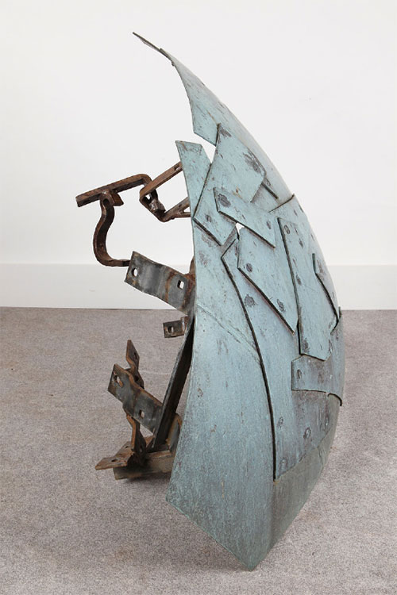

“Color”
Richards attended to every plane-shift, sometimes applying different colors to the edges of relief forms. He used this change expressively and to emphasize the form's three-dimensionality.
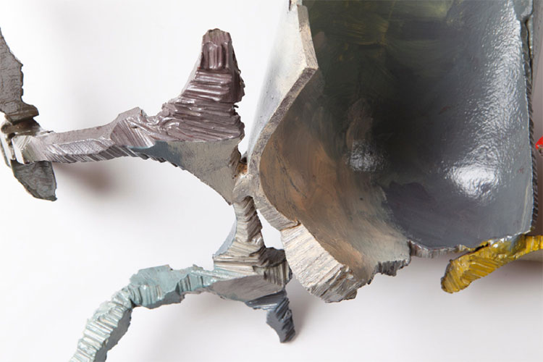
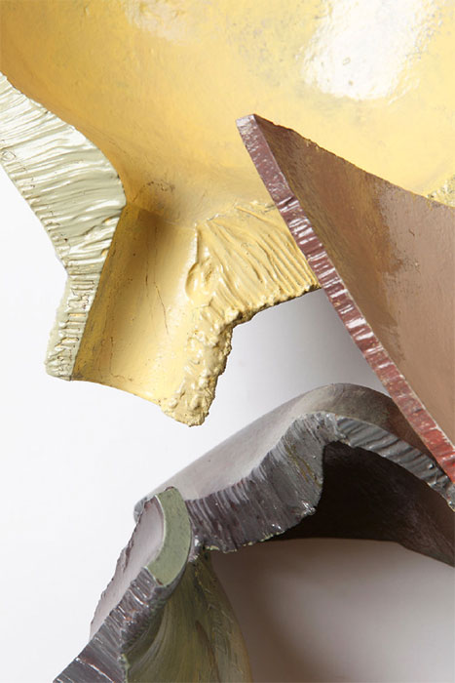

Additional Images from Seeing Sam Richards’ Sculpture

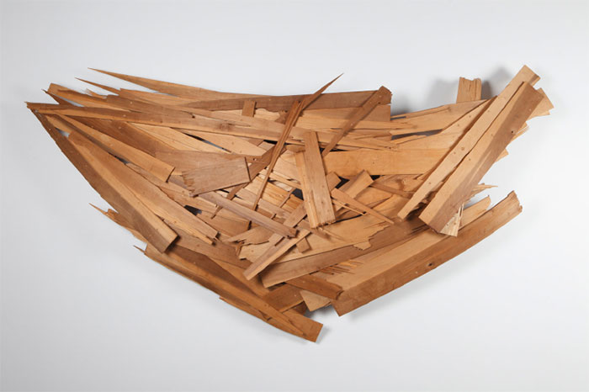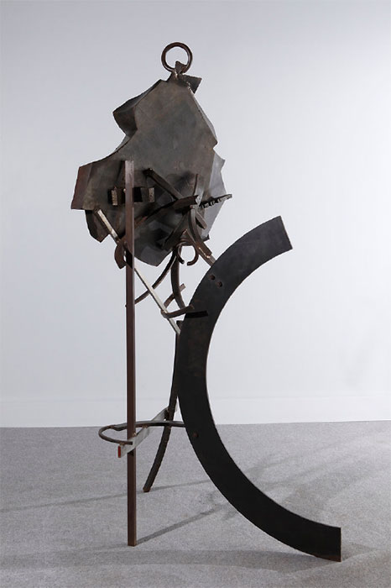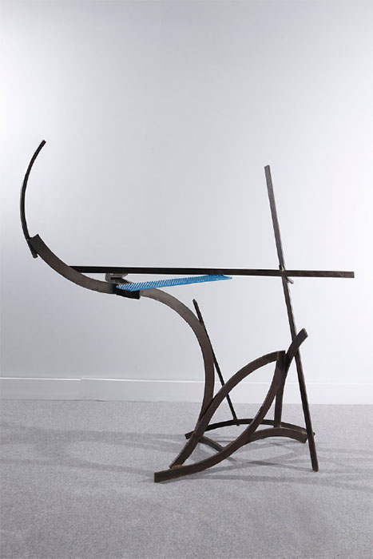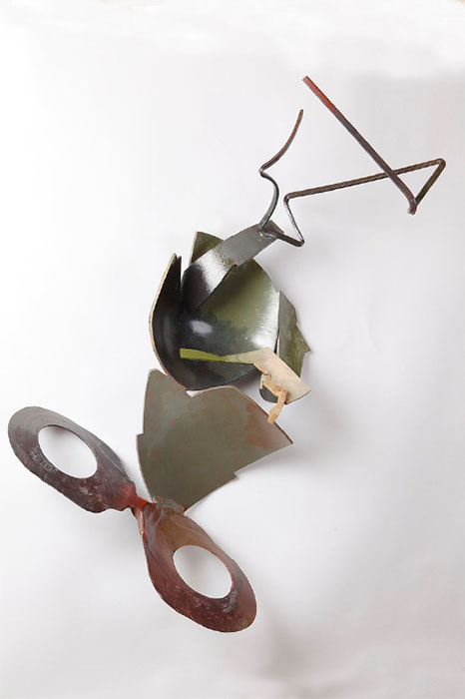
Table of Contents
Preface 10
Introduction - John P. Begley 12
Biography 14

The Sculptor’s Craft 16

Materials, Construction, Surface 21
Kinds of Forms and Compositions 23
Geometric Form 23
Symmetry 24
Organic Form and Composition 26
Found Forms 29
Edges 32
Transitions 35
Physical Connections 38
Visual Connections 48
Separations 50
Bases 56
Stance 59
Gesture 67
Repetition, Pattern, Rhythm, Syncopation 70
Repetition 72
Pattern 78
Rhythm 80
Syncopation 82
Color 86

Developing the Work 102
Drawings and Photographs 103
Sketches for Sculpture 105
Sources 109
Landscape 111
Cityscape and Architecture 114
Still Life 116
Figure 120
Anchors 122
Concave and Convex Form 124

Seeing the Sculpture 127
Anticipating the Future - Jay Kloner 128
Chronological Catalog of Works 130
Vita 186
Hite Exhibition Announcements 190

Appreciation - Scott Massey 192
Appreciations from Former Students 194
Greg Chann, Joseph McGee,
Joseph Smith, Melinda Walters

Acknowledgements 198

About the Author
Louisville sculptor Frances Kratzok received a B.F.A. in sculpture from the Tyler School, Temple University and an M.F.A. in sculpture from Rinehart School of Sculpture of Maryland Institute College of Art.
She has taught sculpture and art classes at several colleges in the Louisville area and exhibits regionally. She was married to sculptor Sam Richards.

Advance Praise
About Seeing Sam Richards’ Sculpture

“I think [this book} is a real contribution to HOW TO SEE ART and would warmly recommend it to any reader, but especially sculpture students. [The author] set up the conditions for a deep and personal interaction between the viewer and the work of art. That is very valuable, and the only real benefit of art criticism of any kind is to make the viewer look more and more deeply.”

Peter Morrin, Director Emeritus, Speed Art Museum

“Sam Richards’ work embraces a language of form which speaks across cultures and time. Through the poetics of sculptural practice, grounded in observation and experience, Richards describes the joy of human existence. His deep understanding of the craft allows for a true mate-rial translation that works with and continues the canon. This book will resonate with those who represent the world through the physical object.”

Joyce Ogden, Artist, Vice President of Academic Affairs and Rounsavall Dean, Kentucky College of Art + Design

“Seeing Sam Richards’ Sculpture is a comprehensive and deeply understanding study of the work of sculptor Sam Richards (1946 -1994). Richards’ work in steel and wood is a reflection of his life-long investigation into the nature of form and material. Working by improvisation he created articulate freestanding and wall sculpture that has strong kinship with the work of Anthony Caro, David Smith, and Issac Witkin. Richards shares with them a love of the non-representational, independent thing – what poet Wallace Stevens called ‘the object at the exactest point at which it is itself’” .1

Timothy J. Segar, Sculptor and Professor Emeritus, Marlboro College

1 An Ordinary Evening in New Haven, Wallace Stevens 1949

“Frances Kratzok takes us into Sam Richards’ creative mind and studio as she dissects every aspect of his sculpture. The dissection provides us with the building blocks artists use as they create. She describes those steps from the smallest weld, grind, and screw to the grand overview of the completed work. From the kind of material and its source to the gallery wall or floor, it is a comprehensive dictionary dedicated to the visual interpretation of sculpture.”

Albert Sperath, Director Emeritus, University of Mississippi Museum

Publicity
Book signing dates to come
NetGalley.com

Author Appearances
Starting Winter of 2022

Distribution
Ingram, Baker & Taylor and most Internet outlets

Media Contact
John H. Clark, publisher
Old Stone Press
E: john@oldstonepress.com
P: 502.693.1506
W: http://oldstonepress.com/

Marketing Materials
High-resolution cover images are available at oldstonepress.com

Websites/Social Media Links
Facebook: https://www.facebook.com/OldStonePress/
Twitter: @oldstoneclark
Instagram: oldstonepress

