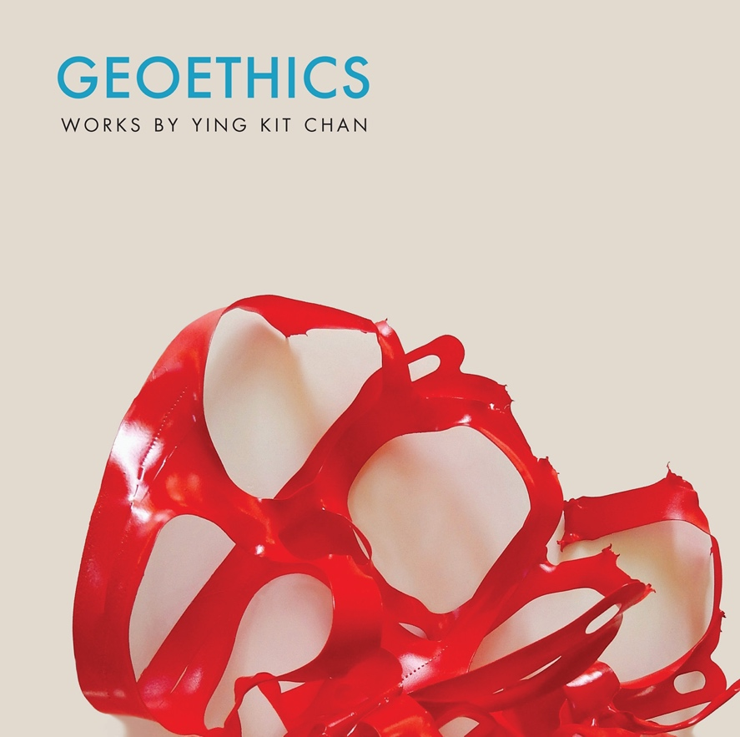

Title: GEOETHICS: Works By Ying Kit Chan
Author(s): Ying Kit Chan
Illustrator: Ying Kit Chan
Publisher: Old Stone Press
Imprint: Old Stone Press
Pub Date: September 9, 2021
ISBN13: 978-1-938462-54-2 (paperback)
ISBN13: 978-1-938462-57-3 (eBook)
Library of Congress: 2020925730
Format: paperback
Trim Size: 8 X 8
Page Count: 158
Carton Qty.: 20
Illustrations: 150+ color
Audience: Trade/General (Adult)
Price: $28.00 Retail (paperback)

BISAC Category: ART063000 ART / Environmental & Land Art
PHI023000 PHILOSOPHY / Environmental Ethics
EDU040000 EDUCATION / Philosophy, Theory & Social Aspects

Introduction
In 1977, Ying Kit Chan’s The Way Is A Void (1977), a woodcut print, was selected by the Hong Kong Museum of Art for the Urban Council Award at the Hong Kong Contemporary Art Biennial. The title of this work was taken from the Chinese classical text Dao De Jing. The teachings of Dao De Jing influenced Chan’s artistic style and conceptual themes, which reflect the spirit of nature and alert of human destruction to our planet.
Along the path of development, his contemplative work also synthesized Western ideas of Romanticism, transcendentalism, existentialism, and phenomenology. While his broad interests in philosophy range from Aristotle, Spinoza, Schopenhauer, Ursula Le Guin to Alain Badiou, his philosophical investigation often leads him back to his roots to intersect with Daoism and Buddhism. The selected images in this book outline several themes and represent varied mediums in Chan’s artistic expression of the subject. Like the order of the universe, this artistic journey has come full circle.
Serving as a professor at the University of Louisville for over three decades, Chan has been able to integrate his professional pursuit with his teaching. As an educator, he is also a pioneer in incorporating new content into the studio art curriculum. He has introduced many new materials and mediums into the classroom such as computer art in the early 1980s, web design and net art in the mid-1990s, and art and sustainability as a studio art course beginning in 2009. He is a member of the International Association for Promoting Geoethics. As exhibited by the span and breadth of his work, his consistent thematic focus on nature has produced a bounty of artistic materials, concepts, and cultural insights.

Author’s Note
Contemporary practice in art is concerned not only with aesthetics but also with ethics. The philosophy of geoethics emphasizes the importance of cultivating our ecological consciousness. Geoethics calls on our ethical responsibility to care for the planet and work toward a harmonious relationship between humankind and the environment. Furthermore, geoethics encourages us to seek out truth within our relationships and to fight for equality and fairness for all humans. The core idea of geoethics is the study of ethics, which is an understanding of morally right actions and our responsibility to the Other.

About the Author
Ying Kit Chan is a Chinese American artist who was born and grew up in Hong Kong. In the 1970s, he studied art in several colleges in Hong Kong. In 1979, Chan continued his studies in the United States and received his BFA from the University of Oklahoma (1981) and MFA from the University of Cincinnati (1983). Between 2003 and 2005, he attended the European Graduate School (Division of Philosophy, Art, and Critical Thought) in Saas-Fee (Switzerland) and Paris, and took seminars with visionary thinkers including Jacques Derrida and Jean Baudrillard.

Chan has presented his artwork in over 200 exhibitions in the United States as well as in Australia, Canada, Ecuador, Germany, Italy, Korea, Japan, England, Hong Kong, Poland, Taiwan, and Portugal. He has received public awards including two Great Meadows Foundation Artist Development Grants (2017 and 2019), two Kentucky Arts Council Al Smith Visual Arts Fellowships (1994 and 2002), a National Endowment for the Arts / Southern Arts Federation Visual Arts Fellowship (1992) and an Urban Council Fine Art Award at the Hong Kong Contemporary Art Biennial (1977). He is Professor of Art at the University of Louisville.

Publicity
Book signing dates to come
NetGalley.com

Author Appearances
Fall of 2021

Distribution
Ingram, Baker & Taylor and most Internet outlets

Media Contact
John H. Clark, publisher
Old Stone Press
E: john@oldstonepress.com
P: 502.693.1506
W: http://oldstonepress.com/

Marketing Materials
High-resolution cover images are available at oldstonepress.com

Websites/Social Media Links
Facebook: https://www.facebook.com/OldStonePress/
Twitter: @oldstoneclark
Instagram: oldstonepress

