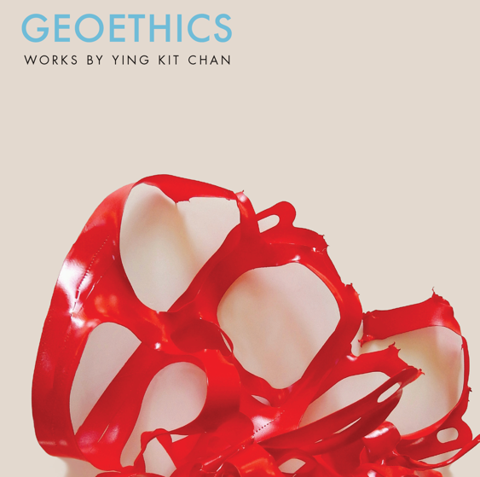
Title: GEOETHICS
Author(s): Ying Kit Chan
Illustrator: Ying Kit Chan
Publisher: Old Stone Press
Imprint: Old Stone Press
Pub Date: Spring 2021
ISBN13: 978-1-938462-54-2 (paperback)
ISBN13: 978-1-938462-N/A
Library of Congress: 2020925730
Format: paperback
Trim Size: 8 X 8
Page Count: 160 approximately
Carton Qty.:
Illustrations: 150+ color
Audience: Trade/General (Adult)
Price: $29.95 Retail (paperback)

BISAC Category: ART063000 ART / Environmental & Land Art
PHI023000 PHILOSOPHY / Taoist
EDU040000 EDUCATION / Philosophy, Theory & Social Aspects

Introduction
In 1977, Ying Kit Chan’s The Way Is A Void (1977), a woodcut print, was selected by the Hong Kong Museum of Art for the Urban Council Award at the Hong Kong Contemporary Art Biennial. The title of this work was taken from the Chinese classical text Dao De Ching. The teachings of Dao De Ching influenced Chan’s artistic style and conceptual themes, which reflect on the spirit of nature and alerts human destruction to our planet.
Along the path of development, his contemplative work also synthesized Western ideas of transcendentalism, existentialism, and phenomenology. His broad interests in philosophy range from Heraclitus, Spinoza, Schopenhauer to Ursula Le Guin. His contemplative framework often leads his direction back to intersect with Taoism. Like the order of the universe, this artistic journey has come full circle.
This Daoist mode of thinking has the affinity for the American environmentalists Rachel Carson and Henry David Thoreau, as well as the modern environmental movement Deep Ecology, which celebrates the richness and diversity of all life forms. Both Deep Ecology and Daoism advocate environmental consciousness that is ecocentric and geocentric.
The selected images in this booklet outline several themes and represent varied mediums in Chan’s artistic expression of the subject. Serving as a professor at the University of Louisville for over three decades, Chan has been able to integrate his professional pursuit with his teaching. As an educator, he is also a pioneer in incorporating new content into the studio art curriculum. He has introduced many new materials and mediums into the classroom such as computer art in the early 1980s, web design and net art in the mid-1990s, and art and sustainability as a studio art course beginning in 2009.

Author’s Note
The philosophy of geoethics emphasizes the importance of cultivating our ecological consciousness. Contemporary practice in art is concerned not only with aesthetics but also with ethics. The core principles of geoethics call on our ethical responsibility in caring for and preserving our planet. With this philosophical basis, Chan’s work seeks to reflect on a harmonious relationship between humankind and the environment.

About the Author
Ying Kit Chan is a Chinese-American artist who was born in Hong Kong. In the ’70s, he studied art in several colleges in Hong Kong. In 1979, Chan continued his study in the United States and received his BFA from the University of Oklahoma (1981) and MFA from the University of Cincinnati (1983). Between 2003 and 2005, he attended the European Graduate School (Division of Philosophy, Art, and Critical Thought) in Saas-Fee (Switzerland) and Paris and has taken seminars with some of the world’s most visionary thinkers including the late Jacques Derrida and Jean Baudrillard.
Ying Kit Chan has presented his artwork in over 200 exhibitions in the United States as well as in Australia, Canada, Ecuador, Germany, Italy, Korea, Japan, England, Hong Kong, Poland, Taiwan, and Portugal. His solo exhibitions include Montevallo University (2018), ArtSpace at Untitled (2016), Jewish Community Center (2015), University of Louisville Cressman Center (2014), INDEXG Gallery (2010, 2007) in Toronto, LEE Gallery in Toronto (2001), Gallery 456 in New York (1999), Taipei Fine Arts Museum in Taipei (1993), Taiwan Museum of Art in Taichung (1992) and A.R.C. Gallery in Chicago (1989). Chan has received public awards including two Great Meadows Foundation Artist Development Grants (1917 and 2019), two Kentucky Arts Council Al Smith Visual Arts Fellowships (1994 and 2002), a National Endowment for the Arts / Southern Arts Federation Visual Arts Fellowship (1992) and an Urban Council Fine Art Award at the Hong Kong Contemporary Art Biennial in 1977. He is Professor of Art at the University of Louisville.

Publicity
Book signing dates to come
NetGalley.com

Author Appearances
Coming Summer of 2021

Distribution
Ingram, Baker & Taylor and most Internet outlets

Media Contact
John H. Clark, publisher
Old Stone Press
E: john@oldstonepress.com
P: 502.693.1506
W: http://oldstonepress.com/

Marketing Materials
High-resolution cover images are available at oldstonepress.com

Websites/Social Media Links
Facebook: https://www.facebook.com/OldStonePress/
Twitter: @oldstoneclark
Instagram: oldstonepress

