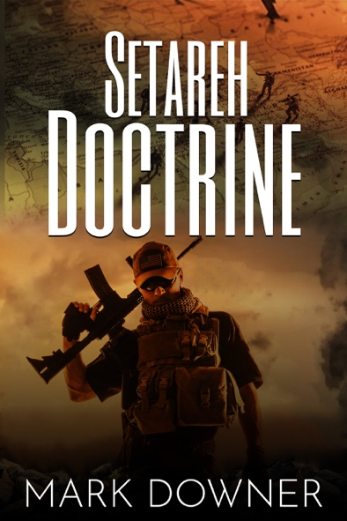
Title: SETAREH DOCTRINE
Subtitle: A Nightmare WWII Weapon Reappears.

Author: Mark Downer
Publisher: Old Stone Press
Imprint: Old Stone Press
Pub Date: June 1, 2021
ISBN13: 978-1-938462- (paperback)
ISBN13: 978-1-938462-51-1 (eBook)
Library of Congress: 2020922811
Format: paperback and ebook
Trim Size: 6 X 9
Page Count: 314
Carton Qty.: 22
Illustrations: N/A
Audience: Trade/General (Adult)
Price: $16.95 Retail (paperback)
$ 7.99 Retail (ebook)

BISAC Category: FIC014050 FICTION / Historical World War II
FIC002000 FICTION / Action & Adventure

Description

A Nightmare WWII Weapon Reappears

In the summer of 1945, on the eve of Japan’s surrender in World War II, converging Allied armies destroyed the infamous Japanese Unit 731 and its evil architect General Daichi Arakawa, whose ominous viral creation had exterminated thousands of Chinese in occupied Manchuria. Nearly twenty-five years later, however, atrocities in rural Cambodia during the Vietnam War hint of the possible resurrection of the insidious biological nightmare, and a culpable participant in those horrors then, foreshadows a potential return of the weapon of mass destruction today.
Armed with the knowledge of its probable existence in the hands of the Islamic Republic of Iran’s Defense Ministry and Revolutionary Guard Corps, People’s Republic of China General Tzu Huang enlists the help of retired General Jake Woods, formerly of the U.S. Defense Intelligence Agency, to help seek out and eliminate those with knowledge of the WMD virus and their attempts to weaponize it. Woods’ ability to cobble together a covert operational team from an eclectic background of elite male and female special ops, intelligence, military, and IT specialists, with help from a wealthy financier and old backchannel contacts in the U.S Department of Defense, produces a formidable stealth force out to tackle the problems our government cannot.
Their subsequent mission takes them on a perilous and deadly pursuit throughout the tyrannical and raging quagmires that are the Middle East, with the fate of the entire “Cradle of Civilization” dependent upon their success. From the explosive origins of the team’s quest and prosecution in Iran, deviating into the ravaged terrains of Iraq and Syria, the chase terminates in southern Lebanon, mission success eluding the "Co-Op team" in a string of near misses until the bitter and unforeseen ending in the mountains of northern Israel.

Dedication

Author Bio

Blessed...and cursed with the creative gene, Mark Downer has always found writing to come naturally, a trait inherited from his father, who he touts as a truly remarkable wordsmith. Having always felt the urge to write and attempt to produce commercially successful prose, the dictates of another career path and raising a family of three children derailed any thoughts of his noble ambition.

Children grown and ownership of a successful and self-sustaining business make that predilection a reality today. With a life full of study and interest in history, particularly the military variety, and a reading library full of some of fiction’s greatest novelists, it only made sense that he pursue his passion drawing upon those inherent experiences, attended by a personal conviction that good always triumphs over evil.

Ghosts of the Past is his first endeavor, created over several years of being drawn back into his creative awakening. It has been the catalyst for his second novel, Setareh Doctrine, which is the first book in the Themis Cooperative thriller series. Look for Caracas Connection to follow shortly.

Publicity
Book signing dates to come

Awards

Author Appearances
Coming Winter of 2021

Distribution
Ingram, Baker & Taylor and most Internet outlets

Media Contact
John H. Clark, publisher
Old Stone Press
E: john@oldstonepress.com
P: 502.693.1506
W: http://oldstonepress.com/

Marketing Materials
High-resolution cover images are available at oldstonepress.com

Websites/Social Media Links
Facebook: https://www.facebook.com/OldStonePress/
Twitter: @oldstoneclark
Instagram: oldstonepress

