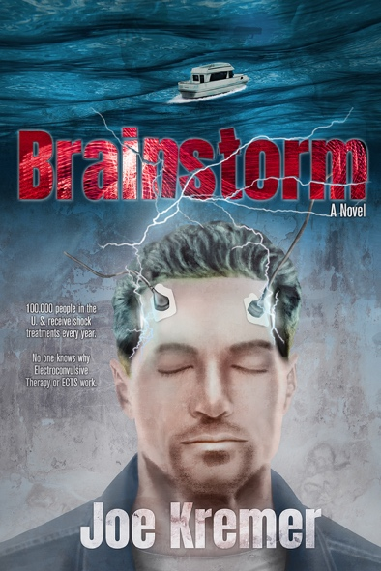
Title: Brainstorm
Author(s): Joe Kremer
Illustrator: Daniel J. Middleton
Publisher: Old Stone Press
Imprint: Old Stone Press
Pub Date: 10/13/20
ISBN13: 978-1-938462-45-0 (paperback)
ISBN13: 978-1-938462-46-7 (eBook)
Library of Congress: 2020913366
Format: paperback and ebook
Trim Size: 6 X 9
Page Count: 225
Carton Qty.:
Illustrations: N/A
Audience: Trade/General (Adult)
Price: $16.95 Retail (paperback)
$ 7.99 Retail (ebook)
BISAC Category: FIC027260 FICTION / Romance / Action & Adventure
FIC031040 FICTION / Thrillers / Medical
FIC027110 FICTION / Romance / Suspense

Description
Paxton Gahl, a friendly, well-meaning emergency medical services (EMS) technician in Louisville, Kentucky, gets a gut punch when his wife says she doesn’t want him anymore. Eight years of marriage, and her parting words are “Sorry, Pax.” Never one to refuse a beer, Paxton makes alcohol his new best friend and looks for a houseboat he can finance and call home. Withdrawn to his boat and sinking into depression, Paxton hits bottom when a mouth sore turns out to be cancer. Electro-shock treatment lifts his spirits and unexpectedly endows him with a strange sixth sense. When injuries, accidents, shootings occur – the events that call for EMS dispatch – Paxton sees these in real time, before anyone contacts 911. His curiously fast response to emergencies leads to heroic and spectacular rescues that draw the attention of Louisville police, especially the attractive Sergeant Malika Kelly. Paxton’s doctors treat his cancer, and Paxton and Malika grow together as action unfolds. Their adventures include a manhunt for a cop-hating sniper, a shootout with a deranged crack head, and a high-tech search for gold booty that was stolen and buried by the deceased former owner of Paxton’s boat. Brainstorm cleverly blends plots and sub-plots, all rich with supporting characters. There’s action, romance, and humor, and an insider’s view of how a city’s public safety agencies – police, 911 dispatch, and EMS – partner in executing their shared mission.

Author’s Note
Ever since a doctor put paddles on either side of my wife's head and pushed a button sending an electrical charge into her brain, I have been intrigued and grateful for electro convulsive therapy (ECT). 100,000 people in the U.S. receive shock treatments every year for severe depression and 70 percent of the time they are effective. What made me want to write a story around this is because nobody really knows why ECTs work.

Dedication
Thanks to my wife Kathy Kremer, the love of my life and the best person I know. Kathy bravely tramped through the high weeds that were the early first drafts of this book and could be relied on to tell me the truth and not just what I wanted to hear.

Author Bio
Before sitting down to write his first book, Joe Kremer set about to collect a wealth of life experience. He earned a degree in cartography and circled the globe as a satellite surveyor for the U.S. Department of Defense. Returning to Louisville, he convinced his high school sweetheart to marry him and became a master bench jeweler. After winning international awards for jewelry design and manufacturing, Kremer returned to his life-long passion, writing. His curiosity about shock therapy came about when his wife, Kathy had that treatment and from hearing stories from a good friend who is an ER psych nurse. Joe Kremer lives in Louisville, Kentucky with Kathy and their anti-social cat Manfred.

This is his first novel.

Illustrator
Daniel J. Middleton began his career in book publishing in 2001 by proofreading and copyediting galley proofs for a small Brooklyn-based press. Since that time, he has developed a love of graphic design and illustration. He has had the pleasure of working with a number of successful self-published authors and small presses with unique offerings. Daniel also writes and illustrates for uniquecoloring.com, his independent, self-owned media company that features inspiring videos, articles, coloring pages, and books celebrating black history and culture.

Publicity
Book signing dates to come

Awards

Author Appearances
Coming Winter of 2021

Distribution
Ingram, Baker & Taylor and most Internet outlets

Media Contact
John H. Clark, publisher
Old Stone Press
E: john@oldstonepress.com
P: 502.693.1506
W: http://oldstonepress.com/

Marketing Materials
High-resolution cover images are available at oldstonepress.com

Websites/Social Media Links
Facebook: https://www.facebook.com/OldStonePress/
Twitter: @oldstoneclark
Instagram: oldstonepress

