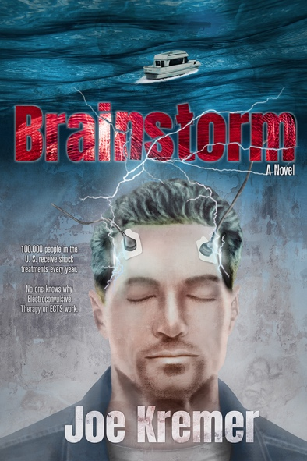
Title: Brainstorm
Author(s): Joe Kremer
Illustrator: Daniel J. Middleton
Publisher: Old Stone Press
Imprint: Old Stone Press
Pub Date: 10/13/20
ISBN13: 978-1-938462-45-0 (paperback)
ISBN13: 978-1-938462-46-7 (eBook)
Library of Congress: 2020913366
Format: paperback and ebook
Trim Size: 6 X 9
Page Count: 225
Carton Qty.: 40
Illustrations: N/A
Audience: Trade/General (Adult)
Price: $16.95 Retail (paperback)
$ 7.99 Retail (ebook)
BISAC Category: FIC027260 FICTION / Romance / Action & Adventure
FIC031040 FICTION / Thrillers / Medical
FIC027110 FICTION / Romance / Suspense

Description
BRAINSTORM is an action-packed romance thriller that touches on the paranormal. Paxton Gahl, an emergency medical services (EMS) technician, leads a modest existence. After five years of riding and driving an ambulance with the Louisville, Kentucky EMS, he dreamily aspires to raise his pay and responsibilities to those of a fully qualified paramedic. Dramatic life changes put Paxton's very survival at risk, and he winds up committed to psychiatric care. To treat him, his doctor chooses electroconvulsive therapy (ECT), formerly known as "electroshock therapy." Paxton's first and only ECT treatment endows him with a freakish sixth sense that will trigger "brainstorms" flashing in his head with ever greater frequency. Paxton's flashes lead to uncommon heroic exploits on the job, earning media coverage. They also attract the attention of Louisville's police and 911 dispatchers, with whom Paxton chooses to communicate under the code name "Vulcan." Is Vulcan a superhero or a super nemesis? Living what is now a drama-filled life, Paxton gets entangled with the attractive Sergeant Malika Kelly and with bank officers desperate to find a fortune in stolen gold coins. Brainstorm delivers action, romance, suspense, and humor, and it also sketches in realistic detail how a city's public safety agencies—police, 911 dispatch, and EMS—work together to execute their shared mission.

Author’s Note
Ever since a doctor put paddles on either side of my wife's head and pushed a button sending an electrical charge into her brain, I have been intrigued and grateful for electro convulsive therapy (ECT). 100,000 people in the U.S. receive shock treatments every year for severe depression and 70 percent of the time they are effective. What made me want to write a story around this is because nobody really knows why ECTs work.

Dedication
Thanks to my wife Kathy Kremer, the love of my life and the best person I know. Kathy bravely tramped through the high weeds that were the early first drafts of this book and could be relied on to tell me the truth and not just what I wanted to hear.

Author Bio
Before sitting down to write his first book, Joe Kremer set about to collect a wealth of life experience. He earned a degree in cartography and circled the globe as a satellite surveyor for the U.S. Department of Defense. Returning to Louisville, he convinced his high school sweetheart to marry him and became a master bench jeweler. After winning international awards for jewelry design and manufacturing, Kremer returned to his life-long passion, writing. His curiosity about shock therapy came about when his wife, Kathy had that treatment and from hearing stories from a good friend who is an ER psych nurse. Joe Kremer lives in Louisville, Kentucky with Kathy and their anti-social cat Manfred.

This is his first novel.

Illustrator
Daniel J. Middleton began his career in book publishing in 2001 by proofreading and copyediting galley proofs for a small Brooklyn-based press. Since that time, he has developed a love of graphic design and illustration. He has had the pleasure of working with a number of successful self-published authors and small presses with unique offerings. Daniel also writes and illustrates for uniquecoloring.com, his independent, self-owned media company that features inspiring videos, articles, coloring pages, and books celebrating black history and culture.

Publicity
Book signing dates to come

Awards

Author Appearances
Coming Winter of 2021

Distribution
Ingram, Baker & Taylor and most Internet outlets

Media Contact
John H. Clark, publisher
Old Stone Press
E: john@oldstonepress.com
P: 502.693.1506
W: http://oldstonepress.com/

Marketing Materials
High-resolution cover images are available at oldstonepress.com

Websites/Social Media Links
Facebook: https://www.facebook.com/OldStonePress/
Twitter: @oldstoneclark
Instagram: oldstonepress

