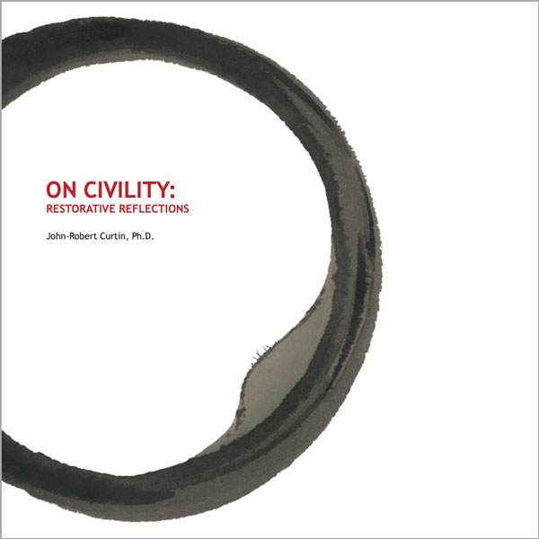
Title: On Civility: Restorative Reflections
Author(s): John-Robert Curtin, Ph.D.
Illustrator: Ying Kit Chan
Publisher: Old Stone Press
Imprint: Old Stone Press
Pub Date: 08/18/20
ISBN13: 978-1-938462-42-9 (paperback)
ISBN13: 978-1-938462-43-6 (eBook)
Library of Congress: 2020901656
Format: paperback and ebook
Trim Size: 8 X 8
Page Count: 94
Carton Qty.: 34
Illustrations: 42 color
Audience: Trade/General (Adult)
Price: $24.95 Retail (paperback)
$ 9.99 Retail (ebook)
BISAC Category: SEL021000 SELF-HELP / Motivational & Inspirational
SEL044000 SELF-HELP / Self-Management / General
POE023000 POETRY Subjects & themes / General
POL064000 POLITICAL SCIENCE / Corruption & Misconduct

Author’s Statement
This collection of poetry centers on my reflections of the concepts surrounding civility, and writing the poems has been restorative to me and to my understanding of this ancient concept.
Beginning with the traditional notion of manners and politeness (George Washington, Rules of Civility & Decent Behavior, 1744), and continuing to the more subtle concepts of compassion, dignity, human value, human worth, forgiveness, and self-dignity, this collection is an attempt to understand and explain a concept that has varied over time and through different cultures. The concept is often connected with civilization and civil because they share the same root word, but civility is more active, more basic, and more personal. “Being civil to one another is much more active and positive a good than mere politeness or courtesy,” (Robert B. Pippin, The Persistence of Subjectivity, 2005).
In order to fully comprehend civility, one must reevaluate the status quo and build on the ancient principles of the interdependence of human beings (Dalai Lama, Beyond Religion, 2011). Civility is therefore interconnected with compassion, justice and humanity.
An important research question when contemplating civility is, “When did human life become disposable, and can we reverse that belief?” As much as civility is typically associated with
qualities such as politeness and the display of good manners, for contemporary social and political theorists it has increasingly come to represent civic virtues such as tolerance, non- discrimination and public reasonableness.
Civility is therefore “more” than good manners (Melanie White, An Ambivalent Civility, Canadian Journal of Sociology, 2006).

Author’s Note
“Conflict is not the problem; conflict is the messenger” ~ Tony Belak, Esquire, Mediator

Dedication
Frederick Smock, Kentucky State Poet Laureate 2017/18, who encouraged me to publish and share this work outside of my classroom.

About the Author
John-Robert Curtin, Ph.D. is a Senior Fellow and Executive Director of the 4Civility Institute, Louisville, Kentucky and 4Civility Institute, Limited, Dublin Ireland. He is also a faculty member at the University of Louisville and at Indiana University and teaches graduate and undergraduate courses in mediation, restorative justice, and alternative dispute resolution.

He is the author of An Exploratory Study of Existing State Anti-Bullying Statutes, (2016), Lambert Academic Press and a contributing author to a two-volume set, “Workplace Bullying and Mobbing” ABC-CLIO, Inc., Santa Barbara, California, January 2018.

4Civility Institute provides mediation training, ombuds training, certifications, software reporting systems, restorative justice, and behavioral transition practice solutions to schools, businesses and organizations. He has extensive experience in alternative dispute resolution, restorative justice, education, training, and in anti-bullying efforts. He also is the founder of the Connected Learning Network, an education-based company, which has provided online services to over 120 schools, colleges, businesses and organizations worldwide. In that capacity, he has been a sub-contractor to 8 European Commission funded projects and numerous U.S. funded projects.

Mr. Curtin is also known for his work in public television, as an Emmy award winning producer and station president. He has over 200 local, national and international programs to his credit. His Ph.D. is from University of Louisville in Alternative Dispute Resolution. His academic background also includes degrees in creative writing and oceanography. He describes himself as a “serial social entrepreneur with an over-commitment addiction”.

John-Robert Curtin began writing as an undergraduate at Syracuse University and had the great good fortune to be in Syracuse University’s poetry writing program and study with Donald Justice, Phillip Booth, and W.D. Snodgrass.

Illustrator
Ying Kit Chan has presented his art work in over 200 exhibitions in the United States as well as in Australia, Canada, Ecuador, Germany, Korea, Japan, England, Hong Kong, Poland, Taiwan, Italy, Switzerland and Portugal. He is presently a professor of art
at the University of Louisville. Inspired by the Deep Ecology philosophy as well as Taoist and Buddhist ideologies, his work celebrates the richness and diversity of all life forms, and contemplates the interconnectivity and harmony of our universe.

Publicity
Book signing dates to come
NetGalley.com

Author Appearances
Coming Summer of 2020

Distribution
Ingram, Baker & Taylor and most Internet outlets

Media Contact
John H. Clark, publisher
Old Stone Press
E: john@oldstonepress.com
P: 502.693.1506
W: http://oldstonepress.com/

Marketing Materials
High-resolution cover images are available at oldstonepress.com

Websites/Social Media Links
Facebook: https://www.facebook.com/OldStonePress/
Twitter: @oldstoneclark
Instagram: oldstonepress

