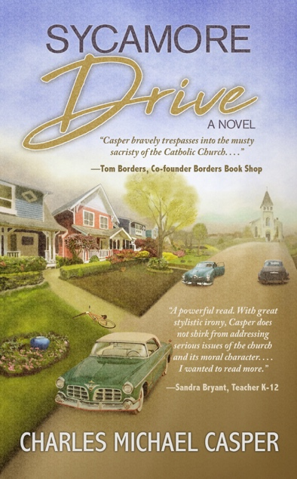
Title: Sycamore Drive: A Novel
Author(s): Charles Michael Casper
Illustrator: Daniel J. Middleton
Publisher: Old Stone Press
Imprint: Old Stone Press
Pub Date: 04/14/20
ISBN13: 978-1-938462-37-5 (paperback)
ISBN13: 978-1-938462-38-2 (eBook)
Library of Congress: 2019912636
Format: paperback and ebook
Trim Size: 5 X 8
Page Count: 188
Carton Qty.: 42
Illustrations: N/A
Audience: Trade/General (Adult)
Price: $14.95 Retail (paperback)
$ 5.99 Retail (ebook)
BISAC Category: FIC042030 FICTION / Christian / Historical
FIC026000 FICTION / Religious
SOC060000 SOCIAL SCIENCE / Sexual Abuse & Harassment

Description
It’s 1955. Eisenhower is President and the Cold War is at its height, yet life on Sycamore Drive in the mid-sized city of Riverport, Illinois seems idyllic and sweet.
Much of the neighborhood’s social life centers on St. Mary’s Catholic Church, its parish school and a group of families that have known each other for generations. But then the revelation of inappropriate interactions with some of the altar boys at the church comes to light. Suddenly, they and their parents are at the center of the emerging sex abuse scandal, a drama that was unimaginable at the time. After all, the priest was seen as God’s representative on earth; the Church was believed to be incapable of harboring evil itself.
And so a story known to us all these years later began to play out, featuring the power and influence of the Catholic Church, the belief that an abuser could be safely reassigned after being sent off to be cured, and then the Church’s unparalleled effort to protect herself
The strange and unanticipated interaction between two families on Sycamore Drive provides the setting for the beginning of this story. It then grows to reveal a brilliant but eccentric neighbor, a courageous teacher at the school, a young priest who dares to look at signs that others ignore, and, of course, the clergy and church leaders who are either naïve or extremely irresponsible – or both.

Author’s Note
It was in early 2002 that the widespread pedophilia scandal within the Catholic Church was first reported by national media. The Archdiocese of Boston was the focus of the these revelations, but ongoing investigations pointed out a pattern of abuse and cover-ups throughout the United States involving priests and lay members of the Catholic Church. Having been raised a Catholic, I was stunned by the news.
It was some time later that, in my view, the abuse seemed to concentrate more on the actions of the “disturbed” abusers and less so on the rights of the victims connected with this tragic scandal, rights that should have been front and center. Not so.
But most importantly, those who orchestrated the cover-up within the Catholic Church seemed to avoid the needed scrutiny. This was the beginning point for my novel, Sycamore Drive.

Dedication
To the courageous and resilient survivors of the sexual abuse crisis within the Catholic Church.

Author Bio
First-time author Charles Michael Casper spent several years on the West Coast in California and Washington State before returning to his hometown of Louisville, Kentucky in the late 1970’s. He began his career in real estate, ultimately co-founding a not-for-profit, affordable housing partnership for low income clients.
This is his first novel.

Illustrator
Daniel J. Middleton began his career in book publishing in 2001 by proofreading and copyediting galley proofs for a small Brooklyn-based press. Since that time, he has developed a love of graphic design and illustration. He has had the good fortune of working with a number of successful self-published authors and small presses with unique offerings. He is the author and illustrator of the Naomi "Redflower" children's book series, which is set in his Central New York hometown.

Publicity
Book signing dates to come
NetGalley.com

Awards

Author Appearances
Coming Winter of 2020

Distribution
Ingram, Baker & Taylor and most Internet outlets

Media Contact
John H. Clark, publisher
Old Stone Press
E: john@oldstonepress.com
P: 502.693.1506
W: http://oldstonepress.com/

Marketing Materials
High-resolution cover images are available at oldstonepress.com

Websites/Social Media Links
Facebook: https://www.facebook.com/OldStonePress/
Twitter: @oldstoneclark
Instagram: oldstonepress

