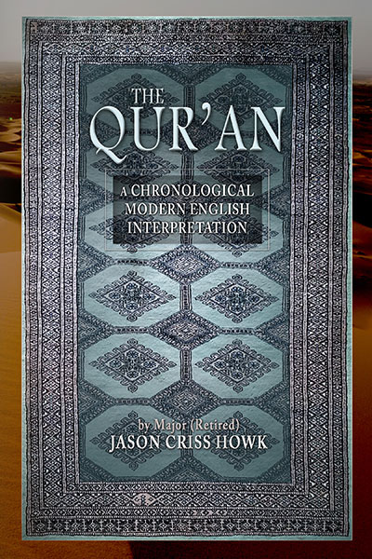
Title: The Qur’an: A Chronological Modern
English Interpretation
Author: Major (Retired) Jason Criss Howk
Publisher: Old Stone Press
Imprint: Old Stone Press
Pub Date: 06/15/17
ISBN13: 978-1-938462-28-3 (paperback)
978-1-938462-30-6 (hardcover)
978-1-938462-31-3 (ebook)

Library of Congress: 2017904866
Format: paperback / hardcover / ebook
Trim Size: 6 X 9
Page Count: 600+
Carton Qty:
Illustrations: Maps / Charts / Graphs
Audience: Religion / History / Political Science / Social Science
Price: $27.95 Retail (paperback)
$39.95 Retail (hardcover)
$ 14.99 Retail (ebook)

BISAC Category: REL041000 RELIGION / Islam / Koran & Sacred Writings
REL037060 RELIGION / Islam / Theology
REL006730 RELIGION / Biblical Studies / Profits
REL037000 RELIGION / Islam / General
HIS026000 HISTORY / Middle East / General
POL059000 POLITICAL SCIENCE / World / Middle Eastern
SOC048000 SOCIAL SCIENCE / Islamic Studies

Advance Reader Copy
This Advance Reader Copy is an uncorrected proof whose price and publication date is subject to change. Reviewers please direct spelling errors, grammar errors, typos or format errors and any general comments about the book to the publisher Old Stone Press, attention John Clark at john@oldstonepress.com

Description and Purpose [author statement]
I wrote this book because I want to help people understand Islam. This is not an attempt to spread a religion or to denigrate it. I offer it as a gift to anyone seeking to bridge the gap in their understanding of Islam. In the end, education and understanding—and acceptance of other cultures—will unite the world against hatred. Let this be a part of that education.

This book is intended for audiences that have very little familiarity with Islam, the Qur’an, or Muslim culture. It also may be beneficial for Muslims that cannot read Arabic but find the current English versions difficult to read.

As a student of Islam and frequent wanderer of the broader Middle East region for over 20 years I have had many an occasion to read the Qur’an, visit mosques, and talk with my acquaintances about Islam. I took advantage of every opportunity in my studies to learn about Islam from many different points of view. I also focused on the little-known “Ibadhi Muslims” of Oman in my postgraduate thesis. While many interpretations of the Qur’an have been written by Muslims (whose first language is usually not English), those translations are often difficult to read. I attempt here to make an easy-to-read version in an unbiased way using modern English.

There are people that feel threatened by Islam as a religion. Some people assume that a Muslim translating the Qur’an into English softens the language to make it more pleasant and less threatening, so they can spread the religion. Other interpreters are even suspected of making the passages sound like God is condoning unlawful violence. On the other side of the equation, many translations or analysis of the Qur’an are done by non-Muslims that seek to find faults in the messages of the Qur’an or vilify the entire religion of Islam.

I seek a middle ground here. My sole intent is to show people what is and is not in the Qur’an and thereby, strictly speaking, what could be expected from a Muslim that adheres to the majority of the teachings of the Qur’an. I think most readers will find that, like all religious people, not all Muslim adherents follow the teachings of the entire Qur’an.

Author/Editor Bio
Major (retired) Jason Criss Howk, is an author, public speaker, adjunct lecturer, and advisor. He focuses on Islam, foreign policy, national security, leadership, and strategy. He retired after 23 years in the U.S. Army operating on joint, interagency, and multinational teams conducting defense, diplomacy, education, and intelligence missions. He holds an MA in Middle East & South Asia Security Studies from the Naval Postgraduate School, studied Dari and Arabic at the Defense Language Institute, and has focused his career on the broader Middle East and the Islamic World. ​ He is a Malone Fellow in Arab and Islamic Studies and a former term member on the Council on Foreign Relations.

During his career, Jason served as an assistant and advisor to three General officers involved with the Afghanistan war. He assisted Karl Eikenberry when he served in Kabul leading the U.S. effort to build the new Afghan National Army and to orchestrate the U.S. and UN led Afghanistan Security Sector Reform (SSR) program. He later assisted Stan McChrystal while he was evaluating and developing the new Afghan War strategy. Finally, Jason assisted Sir Graeme Lamb as he partnered with the Afghan government to develop an internationally supported Afghanistan Peace and Reconciliation process. In all these positions and in many others Jason worked directly with Muslim colleagues from Middle Eastern and South Asian nations and dozens of military and diplomatic officers from the international community.

Jason served on the FAO Journal of International Affairs editorial board, authored a monograph about the development of the International Security Sector Program in Afghanistan, and authored a thesis/book about the Sultanate of Oman (later translated into Arabic). He has written for numerous publications and worked with various media outlets. He is a writer-in-residence at Weymouth and a member of the George C. Marshall Foundation. Jason earned a governmental success medal from Afghanistan and has been honored with the Legion of Merit and two Bronze Star Medals, among other awards, from the U.S. Government. In his spare time, he mentors young adults seeking careers in foreign policy and national security.

He is currently leading interfaith dialogues across the United States to educate people about the differences among the religion of Islam, the concept of Islamism as a political ideology, and the deadly ideology followed by the modern global network of violent radical Islamist groups. His aim is to increase interreligious understanding and promote peaceful coexistence.

Publicity
American Library Association (ALA)
Conference June 22 - 27
Independent Book Publishers Association Booth Book Launch and Meet the Author Book Signing

Other book signing dates to come

Awards
Applied

Author Appearances
Coming Summer of 2017

Distribution
Amazon.com, other popular Internet outlets, Baker & Taylor and Ingram

Marketing Materials
High-resolution cover images are available at oldstonepress.com

Websites/Social Media Links
Author Blog / Website: https://dispatchesfrompinehurst.com/

Facebook: https://www.facebook.com/DispatchesFromPinehurst/

Twitter: https://twitter.com/jason_c_howk

Qur'an project Go Fund Me page
https://www.gofundme.com/jason-howks-quran-interpretation

Other Publication Appearances

Task and Purpose
http://taskandpurpose.com/author/jason-criss-howk/

The Strategy Bridge
https://thestrategybridge.org/the-bridge/?author=5670eb1ba12f44d7686550df

Media Contact
John H. Clark, publisher
Old Stone Press
E: john@oldstonepress.com
P: 502.693.1506
W: http://oldstonepress.com/

About Old Stone Press
OLD STONE PRESS is an author services company that specializes in publishing single-authored books or multi-authored, highly illustrated coffee table books. Founded in 2012 by
J. H. Clark in Louisville, Kentucky, Old Stone Press aspires to capture the stories of people, places, and things that educate and inspire good conversation. www.oldstonepress.com

