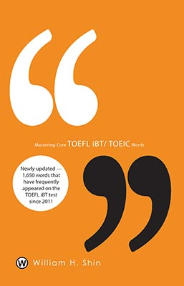
Title: Mastering Core TOEFL iBT/TOEIC Words
Subtitle:

Author(s): William H. Shin
Series:

Publisher: Old Stone Press
Imprint: Old Stone Press
Pub Date: April 15, 2015
ISBN13: 978-1-938462-08-5 (paperback)

Season:
Format: paperback
Trim Size: 5.5 X 8.5
Page Count: 486
Carton Qty:
Illustrations:
Audience: English as a second language
Previous Edition ISBN:
Price: $34.95
BISAC Category: EDU005000 Education / Bilingual
FOR007000 FOREIGN LANGUAGE STUDY / English as a Second Language

Description
This book contains as many as 1,650 core TOEFL iBT/ TOEIC words along with synonyms, definitions, example sentences, and 29 different reviews provided by my colleagues and students. In order to help students preparing for the TOEFL iBT/ TOEIC to memorize the words more effectively, certain words have stars (*), which indicate the degrees of difficulty of memorizing them. Based on Mr. Shin's long-term TOEFL/ TOEIC teaching experience, students preparing for the TOEFL iBT/ TOEIC must precisely learn the definitions of the core TOEFL iBT/ TOEIC words in this book to enhance their TOEFL iBT/ TOEIC scores. Once students have memorized all the words, they will be able to start dealing with questions from the reading, writing, listening, and speaking sections more easily and efficiently. This book will enable students to become better TOEFL iBT/ TOEIC test takers.

Author
William H. Shin is Founder CEO and Education Consultant of Knowledge Tree Education LLC. He is a SAT/SSA/TOEFL iBT instructor. He currently is the Academic Coordinator and ESL/TOEFL iBT Instructor (Reading, Listening, Speaking and Writing) at CAMPUS Education in Palisades Park, NJ.He has a Bachelor of Arts (BA) from Hankook University of Foreign Studies, Seoul Korea with a Major in Russian Language and Literature. He has a Masters of Arts (MA) from New York University, Graduate School of Arts and Science with a major of Russian and Slavic Studies and literature. Also from New York University, Steinhardt Graduate School of Education, NY TESOL in School of Culture, Education and Human Development. In addition, he has Matriculated in Advance Certificated Program at New York University with a major TESOL (Teachers of English to Speakers of Other Languages).

Publicity
Out for review

Awards
N/A

Author/Editor/Publisher Appearances
Soon to be announced

Distribution
Ingram, Baker and Taylor and popular Internet outlets

Media Contact
J. H. Clark, editor/publisher, Old Stone Press
Phone: 502.693.1506
Email: john@oldstonepress.com
Web site: http://www.oldstonepress.com

Marketing Materials/Promotion
High-resolution cover images are available at oldstonepress.com
Marketing plan that includes radio interviews, space advertising and Ingram Advance catalog insertions

Websites/Social Media Links

Facebook: http://www.amazon.com/Mastering-Core-Words-William-Shin/dp/1938462033

About Old Stone Press
OLD STONE PRESS is an author services company that specializes in publishing single-authored books or multi-authored, highly illustrated coffee table books. Founded in 2012 by J. H. Clark in Louisville, Kentucky, Old Stone Press aspires to capture the stories of people, places, and things that educate and inspire good conversation. www.oldstonepress.com

