Title: David Iacovazzi-Pau
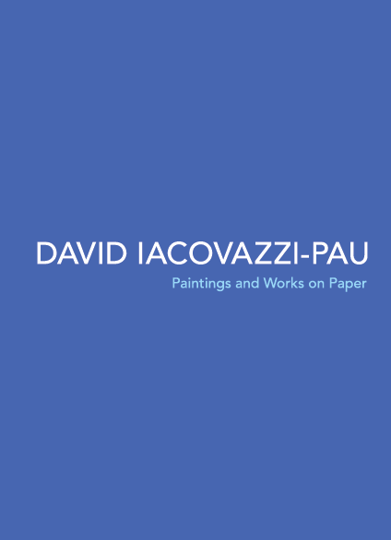
Subtitle: Paintings and Works on Paper
Author(s): David Iacovazzi-Pau
Series:
Publisher: Old Stone Press
Imprint: Old Stone Press
Pub Date: 07.15.15
ISBN13: 978-1-938462-18-4
Season: All
Format: Paperback
Trim Size: 8 X 10.88
Page Count: 70
Carton Qty:
Illustrations:
Audience:
Previous Edition ISBN:
Price: $24.95
BISAC Category: ART006000: Collections, Catalogs, Exhibitions – General
ART006010: Collections, Catalogs, Exhibitions – Group Shows
ART016000: Individual Artists - General

Description
This catalogue was published on the occasion of a traveling exhibition of the portraits of David Iaccovazzi-Pau. The featured artworks celebrate members of the Louisville, Kentucky artistic community, who through their creativity, support, and passion for the arts are truly the life-blood of this community. The desire of Iacovazzi-Pau to feature these individuals illustrates his deep commitment to the arts that is engrained in his being and led him to seek out relationships with fellow artists and to absorb exhibitions, performances and artistic theory and history, in addition to honing his own skill. The many plates included in this catalogue show the range of Iacovazzi-Pau and the evolution of his style over four years and serve as a wonderful tool for studying the artist's works on paper and paintings as an accompaniment to viewing the works in person.

Author/Editor Bio
David Iacovazzi-Pau: http://www.davidiacovazzipau.com/resume/

Publicity

http://www.davidiacovazzipau.com/press/

Awards
See resume and web site

Author Appearances
July 24 – September 26, 2015: Carnegie Center for Art, New Albany, Indiana
November 6 – December 12, 2015: Swanson Contemporary Gallery, Louisville, Kentucky
January 3 – February 9, 2016: Patio Gallery, Louisville, Kentucky

Distribution
Baker & Taylor, Ingram, Amazon.com and other popular Internet web sites

Media Contact
J. H. Clark, editor/publisher, Old Stone Press
Phone: 502.693.1506
Email: john@oldstonepress.com
Web site: http://www.oldstonepress.com

Marketing Materials
High-resolution cover images are available at oldstonepress.com

Websites/Social Media Links
http://www.davidiacovazzipau.com/

About Old Stone Press
OLD STONE PRESS is an author services company that specializes in publishing single-authored books or multi-authored, highly illustrated coffee table books. Founded in 2012 by J. H. Clark in Louisville, Kentucky, Old Stone Press aspires to capture the stories of people, places, and things that educate and inspire good conversation. www.oldstonepress.com

