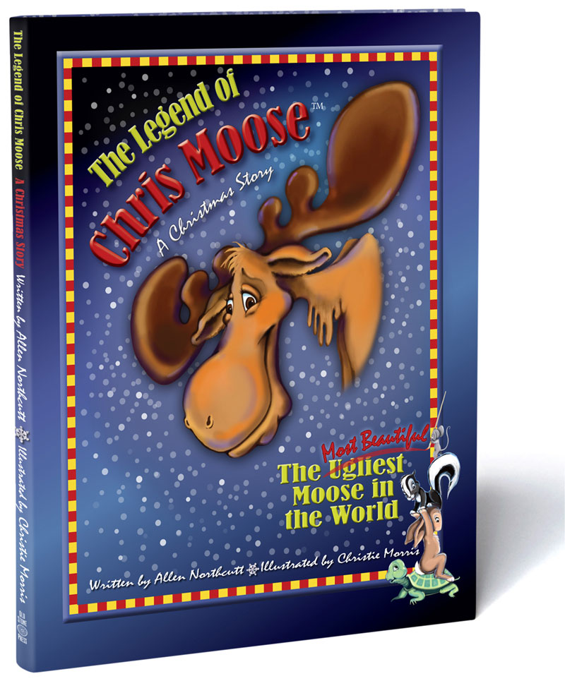
Title: The Legend of Chris Moose
Author(s): Allen Northcutt
Publisher: Old Stone Press
Imprint: Old Stone Press
Pub Date: 11/15/12
ISBN13: 978-1-938462-01-6 (hardcover)
978-1-938462-02-3 (eBook)
Season: Holiday
Format: Hardcover
Trim Size: 8.3 x 10.5 x .04 inches
Page Count: 48
Carton Qty: 25
Illustrations: Fully-illustrated Picture Book
Audience: Juvenile, Beginning Readers
Price: $17.95
Basic Category: JUV017010 Juvenile Fiction,
Holidays & Celebrations, Christmas

Description
Author Allen Northcutt’s fun-filled holiday tale weaves a whimsical ugly duckling story of animal friends that love an amiable but tattered moose whose name is Ugly. This picture book introduces eleven animal characters in rhyme as they join Ugly on a snowy trip through the woods to the house of Momma and Poppa Bear. There, a Christmas Eve party is made very special when Ugly gives unselfishly of himself to make up for a forgotten Christmas tree.

The story addresses everyday issues of how ugly names are hurtful and it is not nice to exclude someone from a group because they are different. In the end the animals embrace Ugly as part of their group and change his name to Chris Moose, because it sounds so much like “Christmas,” and Christmas is what his spirit is all about. Christie Morris’ captivating and humorous illustrations add magic to this soon-to-be-classic Christmas story.

Author/Contributors
AUTHOR: Allen Northcutt wrote the first draft of The Legend of Chris Moose on Christmas Eve in 1982 while dealing with the many issues of raising a learning-disabled child. And then the manuscript sat in a drawer for twenty-nine years. Allen is a decorated U.S. Marine Corps fighter pilot, Vietnam War veteran, and retired investment banker. His enduring passions are the outdoors, adventure recreation, competitive sports, and spending quality time with family and old friends. Motivation to resurrect Chris Moose came from friends’ encouragement that Chris Moose could become the first new perennial Christmas character in the past fifty years.
DESIGNER & ILLUSTRATOR: Christie Morris has worked in an artistic career for over 30 years. She is an author/illustrator, as well as a conceptual artist/designer for theme park features. Christie grew up on a horse farm where she acquired a love of animals. Observing animal behavior has served her well in creating fictional pieces that depend on animals as the major characters.

Awards/Publicity
“In The Legend of Chris Moose, Allen Northcutt creates a delightful, beautifully illustrated moose tale that gives parents and children an opportunity to discuss the issue of social exclusion and the hurtfulness of name-calling.”
Lauren Kramer for Foreword Reviews (5-Stars)
https://www.forewordreviews.com/reviews/the-legend-of-chris-moose/
“The Legend of Chris Moose, a simple moral story of bullying and name calling and self-empowerment contained in Hans Christian Andersen’s original tale..... is an adorable update of a classic fairy tale and introduces a memorable new character to the festive bookshelves.”

Kent Lane for IndieReader
https://indiereader.com/book_review/the-legend-of-chris-moose/

Events
Check back for upcoming events

Distribution
Baker & Taylor, Ingram, Barnes & Noble, Amazon

Websites/Social Media Links
https://oldstonepress.com/library/the-legend-of-chris-moose/
https://twitter.com/oldstoneclark
https://www.facebook.com/LegendofChrisMoose
https://twitter.com/LegendofCMoose
https://www.instagram.com/legendchrismoose/

