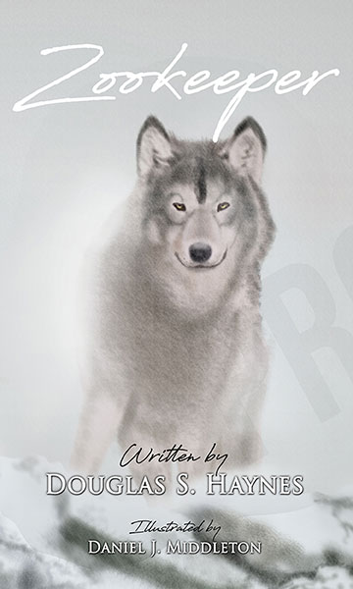
Title: Zookeeper
Author(s): Douglas S. Haynes
Publisher: Old Stone Press
Imprint: Old Stone Press
Pub Date: 10/16/18
ISBN13: 978-1-938462-34-4 (hardcover)
Library of Congress: N/A
Format: Hardcover + dustjacket
Trim Size: 5 X 8
Page Count: 22
Carton Qty.:
Illustrations: 8 color
Audience: Trade/General (Adult/Children)
Price: $19.95 Retail (hardcover)

BISAC Category: POE023030 POETRY / Subjects &
Themes / Nature

Description
Zookeeper is a timeless free verse poem that encourages us to order our lives like the zoo and the pattern found in nature.

Author Bio

Douglas S. Haynes is a practicing attorney who began writing poetry in 2011. Zookeeper was the product of his need to impart advice at the onset of his daughter’s freshman college year. She hung the poem in her dorm room.

Haynes went on to study poetry with Frederick Smock. “Louisville Bar Briefs” regularly publishes his law poems, which explore the practice of law from the attorney’s vantage point.

A native of Louisville, Kentucky, Haynes received his undergraduate degree at Davidson College. He earned a Masters of Social Work from Columbia University and then studied law at the University of Washington in Seattle. He spent one year as a cab driver in Manhattan, and he hiked the Appalachian Trail in its entirety. He now resides in Louisville where he practices Family Law and Mediation.

Dedication
This is dedicated to my daughter Carson, whose journey to college years ago unleashed in this poet an urgency to offer advice. She hung this poem on her dorm wall freshman year.

Publicity
Book signing dates to come

Awards

Author Appearances
Coming Fall of 2018

Distribution
Ingram, Baker & Taylor and most Internet outlets

Media Contact
John Clark, publisher
Old Stone Press
E: john@oldstonepress.com
P: 502.693.1506
W: http://oldstonepress.com/

Marketing Materials
High-resolution cover images are available at oldstonepress.com

Websites/Social Media Links
Facebook: https://www.facebook.com/OldStonePress/
Twitter: @oldstoneclark
Instagram: oldstonepress

